Streaming Architecture

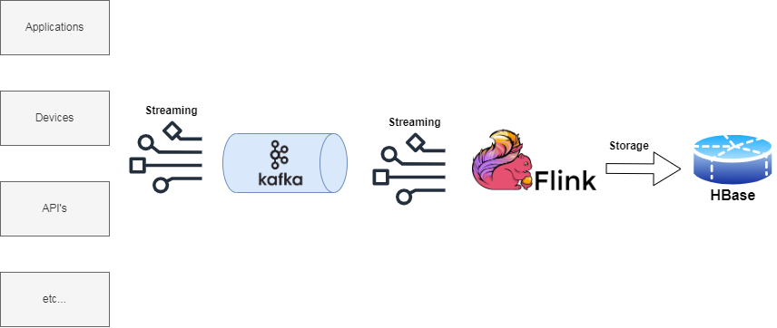

The architecture is composed by the following technologies for streaming and analyze data in real-time:

* Applications, Devices, API's etc... are the data source where the data comes from.
* Apache Kafka, a distributed event store and stream-processing platform. Kafka can connect to external systems (for data import/export) via Kafka Connect and provides the Kafka Streams libraries for stream processing applications.
* Apache Flink, an open-source, unified stream-processing and batch-processing framework. The core of Apache Flink is a distributed streaming data-flow engine. It provides a high-throughput, low-latency streaming engine as well as support for event-time processing and state management
* HBase is an open-source non-relational DBMS. It provides a fault-tolerant way of storing large quantities of sparse data. It's a column-based database.